Assignment II

Question1

(A)

(a)

|  |  |
| --- | --- |
| Charter | char_trip |
| Aircraft | ac_number |
| Model | mod_code |
| Pilot | emp_num |
| Employee | emp_num |
| Customer | cus_code |

(b)

|  |  |
| --- | --- |
| Charter | char_trip + char_date |
| Aircraft | ac_number + mod_code |
| Model | mod_code + mod_name |
| Pilot | emp_num + pil_license |
| Employee | emp_num + emp_lname |
| Customer | cus_num + cus_lname |

(c)

|  |  |
| --- | --- |
| Charter | no other candidate keys |
| Aircraft | same as above |
| Model | same as above |
| Pilot | same as above |
| Employee | perhaps emp_lname + emp_fname + emp_dob will do but still have chance not. |
| Customer | cus_phone |

(d)

|  |  |
| --- | --- |
| Charter | char_pilot  char_copilot  ac_number  cus_code |
| Aircraft | mod_code |
| Model | none |
| Pilot | emp_num |
| Employee | none |
| Customer | none |

(e)

Secondary Key is the key that has not been selected to be the primary key. However, it is considered a candidate key for the primary key. So it should be the same answer with (c).

(D)

(E)

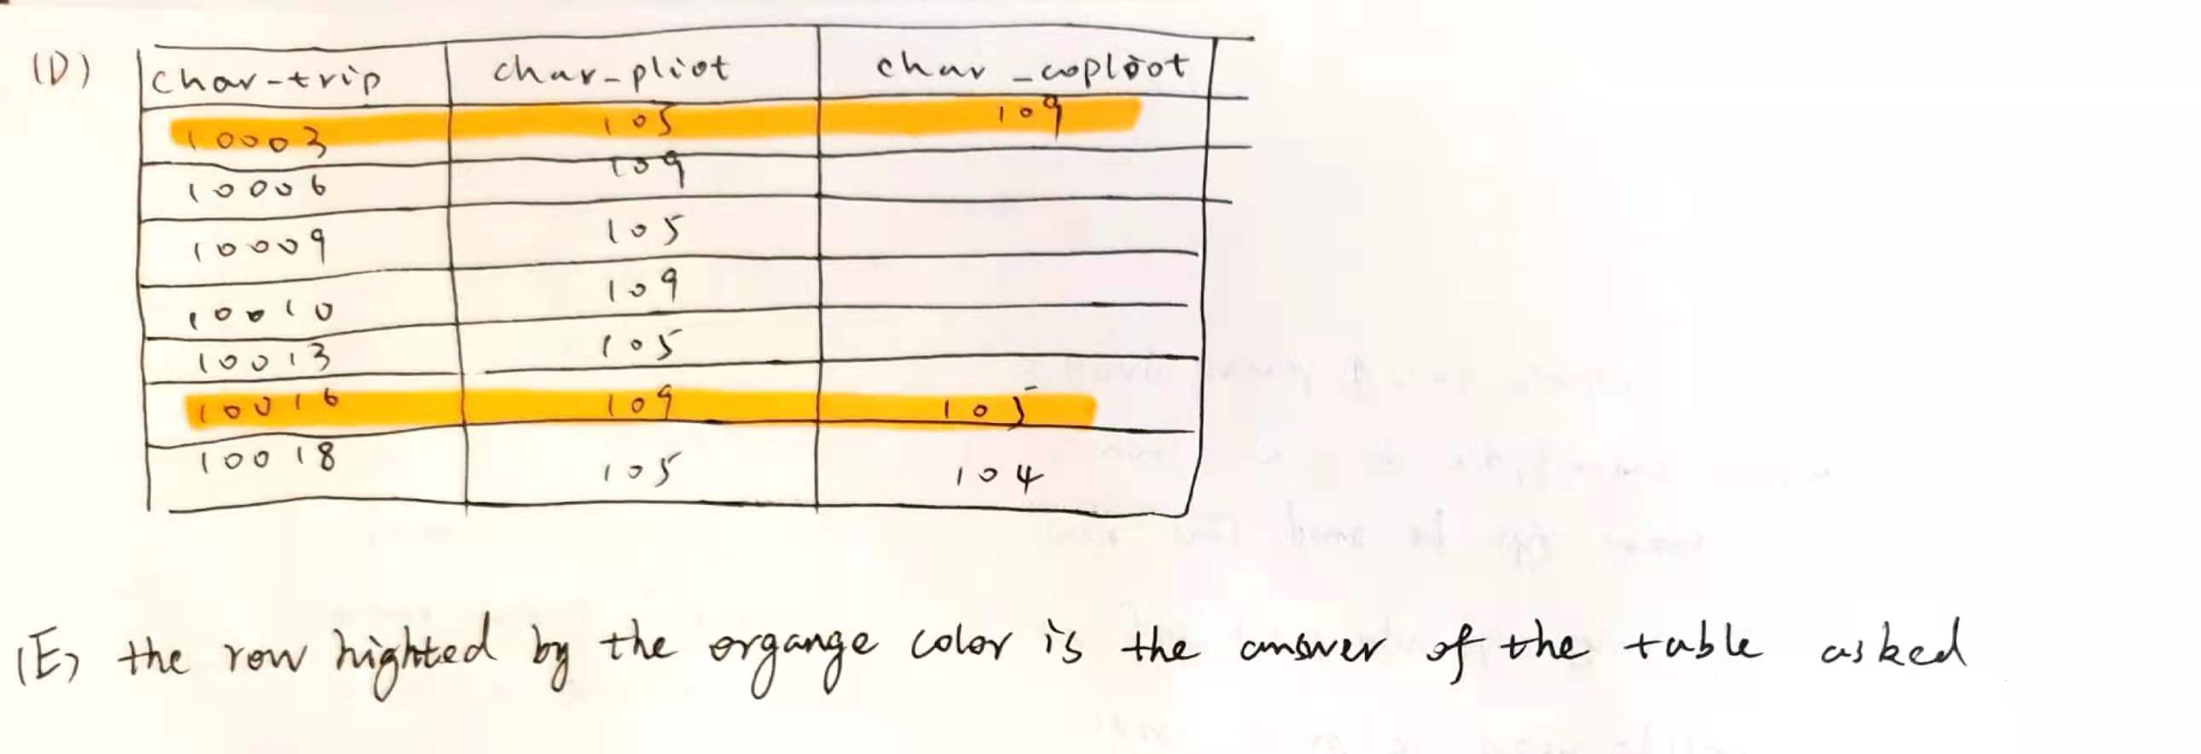

Question2

Question3